**United States Department of Agriculture**

Food and Nutrition Service

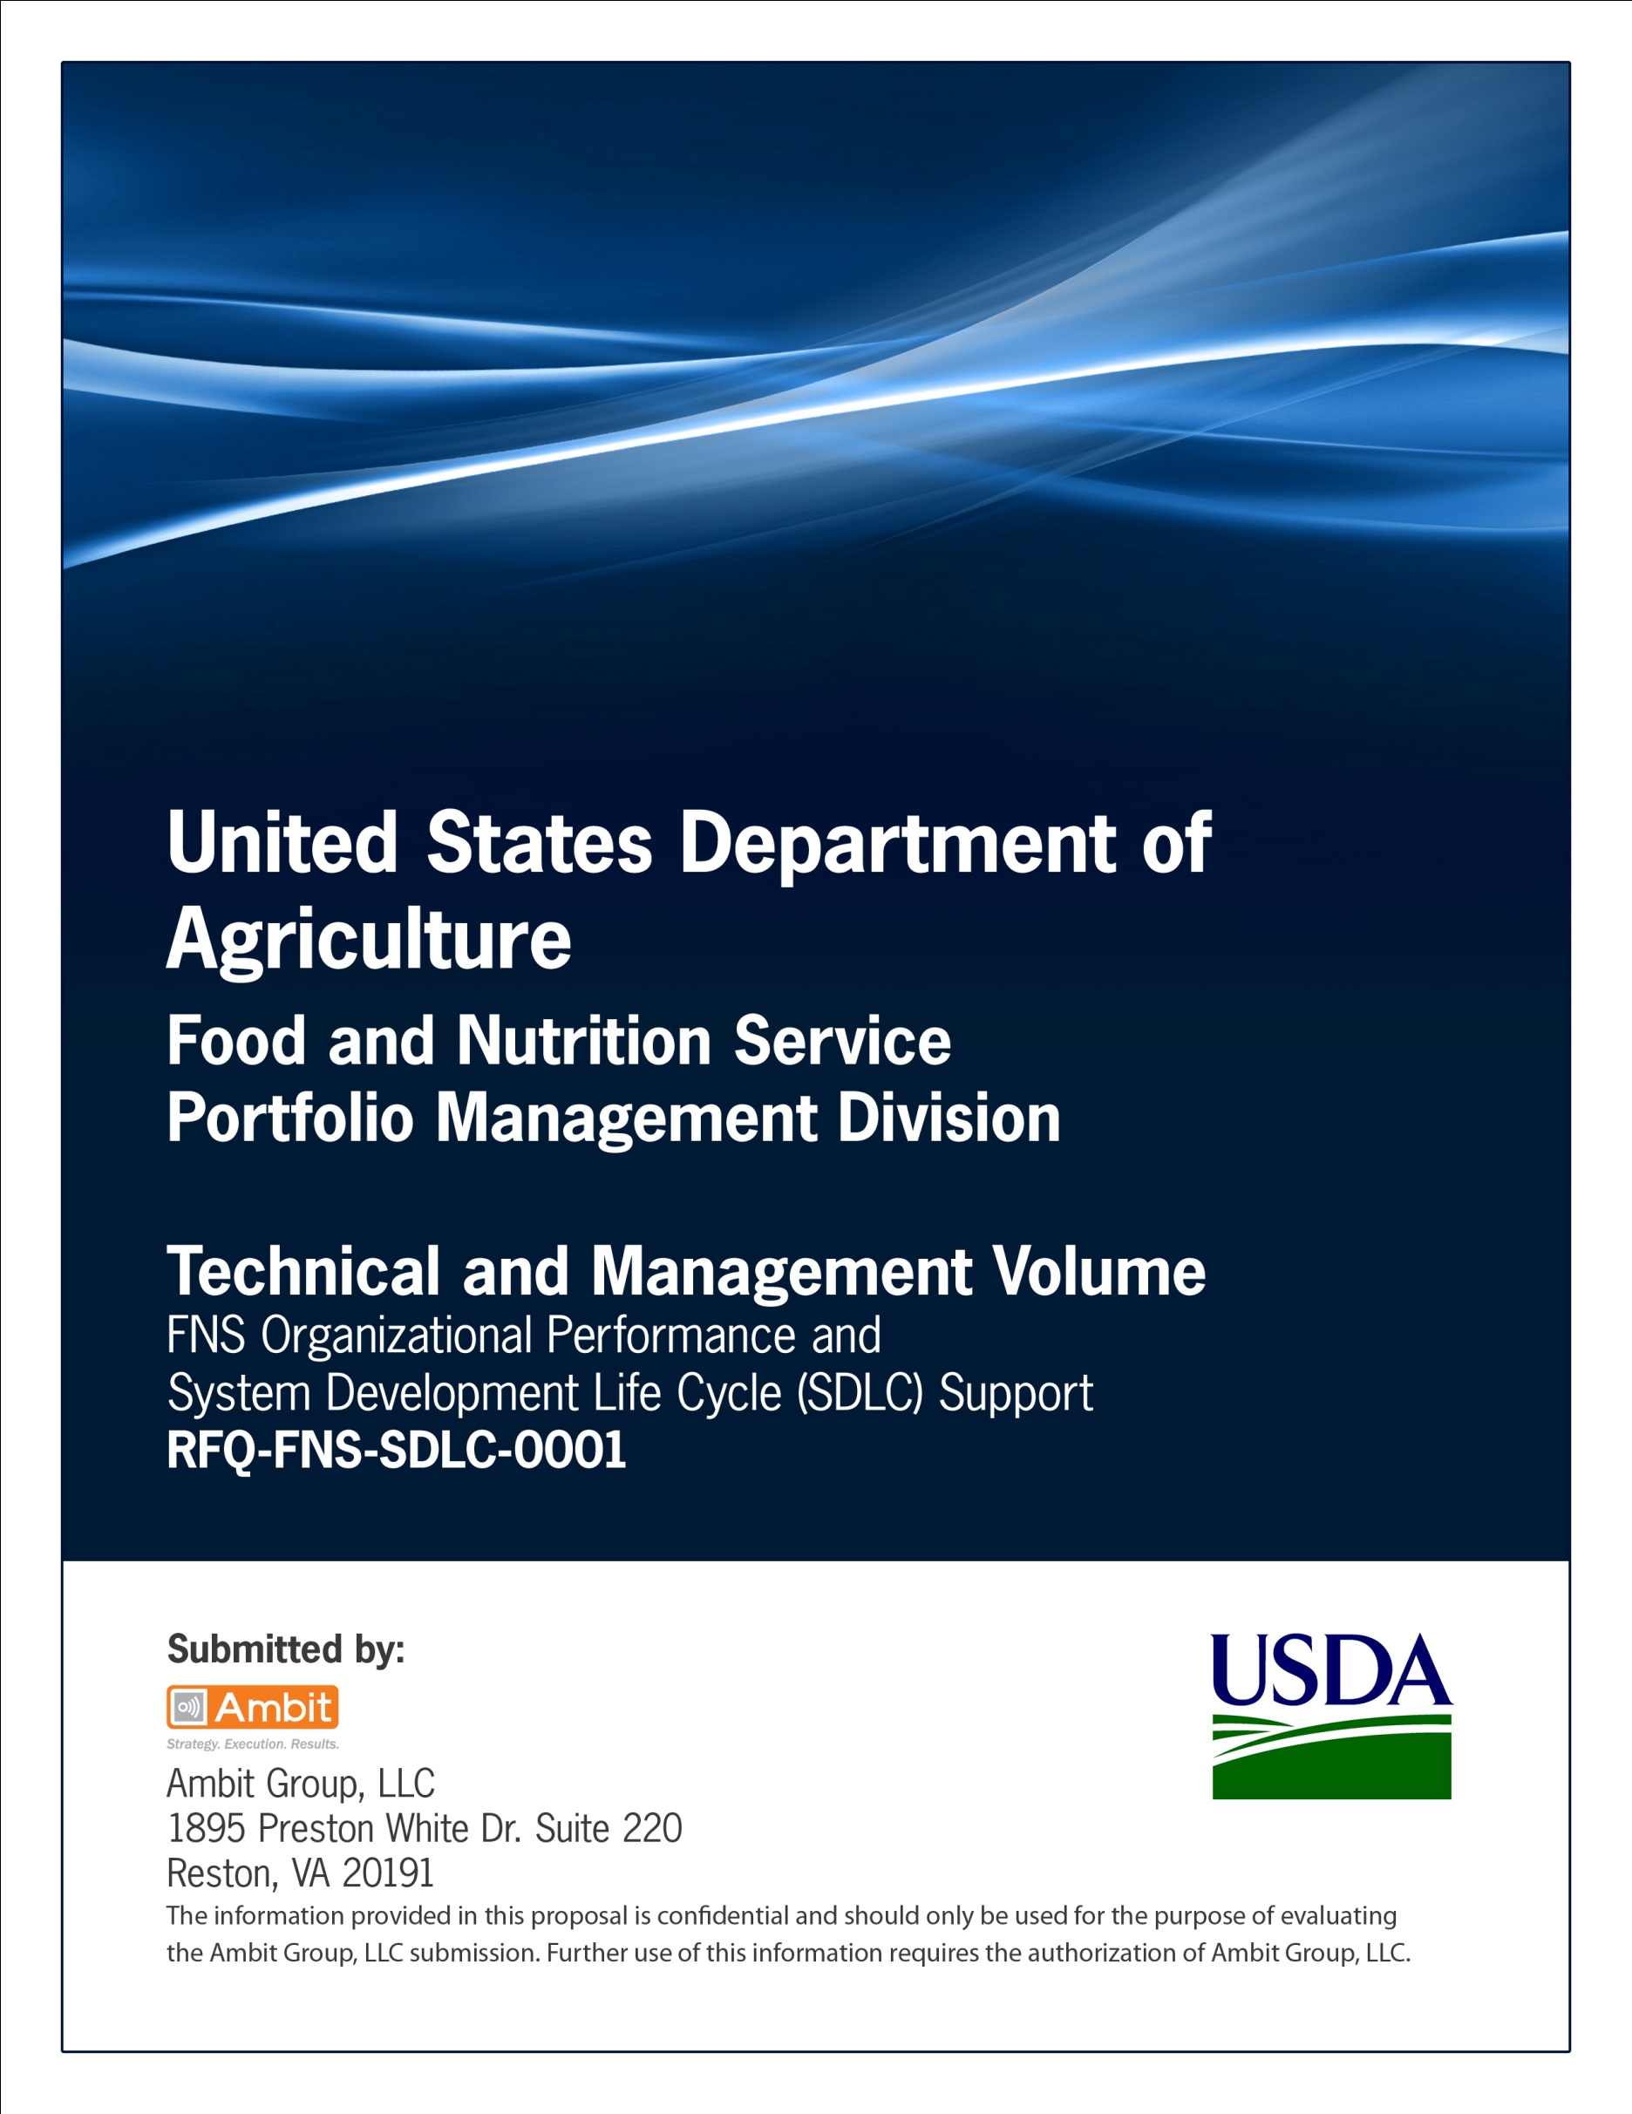

**FNS Office of Information Technology**

**Portfolio Management Division (PMD)**

**FNS Project Closeout Template**

**for**

**[Project or System Name]**

**Version 1.1**

September 09, 2013

**Revision History**

|  |  |  |  |
| --- | --- | --- | --- |
| **Version** | **Date** | **Author** | **Change Description** |
| 1.0 | 03-19-2013 | IT Governance Branch (ITGB) | Created the document |
| 1.1 | 09-09-2013 | IT Governance Branch (ITGB) | Re-formatted the document. |
| 1.2 |  |  |  |
| 1.3 |  |  |  |

**Contact Information**

|  |  |
| --- | --- |
| **Area of Concern** | **Contact Person** |
| IT Governance Lead | Kevin Russ |
| SDLC Coordinator | Syed Jaffery |
| ITIRB Coordinator | Sunny Dilawari |
| Portfolio Management Division Director, Chief Portfolio Officer | Jacqueline Butler |
| Program Management Branch Chief | Allison Willcox |

Contents

Glossary 4

1. General Project Information 5

2. Schedule and Financial Information 5

3. Resource Information 6

4. Final Product or Service Acceptance Information 7

5. Open Issues 8

6. Lessons Learned Report 9

Appendix A: References 10

Approvals/Signatures 11

# Glossary

| **Acronym** | **Description** |
| --- | --- |
|  |  |
|  |  |
|  |  |
|  |  |
|  |  |
|  |  |
|  |  |
|  |  |

# General Project Information

|  |  |
| --- | --- |
| **Project Name and Acronym** | |
|  | |
| **Project Purpose (limit to 35 words or less)** | |
|  | |
| **Portfolio** | **Program** |
|  |  |
| **Sponsor** | **Organization** |
|  |  |
| **Business Lead** | **Organization** |
|  |  |
| **OIT Project Manager** | **Organization** |
|  |  |
| **System Development Lead** | **Organization** |
|  |  |

# Schedule and Financial Information

Respond to each question. For each “No” response, include an issue in the Open Issues section.

|  |  |  |  |  |
| --- | --- | --- | --- | --- |
| Planned Start Date |  | | Actual Start Date |  |
| Planned Finish Date |  | | Actual Finish Date |  |
| Funding Sources (examples of funding sources are: Program, OIT, Development, O&M, etc.) | |  | | |
| Resources Used | | ⬜ Govt. Staff ⬜ Contractor ⬜ Other | | |
| If Other is checked, specify resource(s) here: | |  | | |
| Have all Contracts/Task Orders been closed? | | ⬜ Yes ⬜ No ⬜ Not Applicable  (If No is checked, list names in this block and describe in the Open Issues section.) | | |
| Have all unused funds been deobligated? | | ⬜ Yes ⬜ No  (If No is checked, list why in the Open Issues section) | | |
| Has the Operations & Maintenance handoff been completed? | | ⬜ Yes ⬜ No ⬜ Not Applicable | | |

|  |  |  |
| --- | --- | --- |
| What was the original project budget? (in thousands) | What amounts were obligated (in thousands) and on what date(s)? | |
| Amount | Date |
|  |  |  |
|  |  |  |
|  |  |  |

Explain any variances below:

# Resource Information

Respond to each question. For each “No” response, include an issue in the Open Issues section.

| **Question** | **Response** |
| --- | --- |
| Have all resources (including, but not limited to, staff, contractors, hardware, software, tools) been appropriately released? | Yes  No |
| Have all applicable SDLC artifacts been completed/finalized and uploaded to the appropriate tool/archive? | Yes  No |
| Have all products and documentation been turned over to the appropriate group or organization? | Yes  No |

# Final Product or Service Acceptance Information

Respond to each question. For each “No” response, include an issue in the Open Issues section.

| **Question** | **Response** |
| --- | --- |
| Was this product or service successfully deployed and are users successfully able to use the product or service? | Yes  No |

For Major Deliverables that were not accomplished, include information in the Open Issue section.

| **Question** | **Accomplished?** |
| --- | --- |
| What were the Major Deliverables (with Latest Version Number and Date)?  List Here: | Yes  No |
| Is there a follow-on effort associated with this project? If yes, please describe it below. | Yes  No |

# Open Issues

| **Issue #** | **Open Issue Description** | **Assigned To** | **Proposed Resolution** |
| --- | --- | --- | --- |
|  |  |  |  |
|  |  |  |  |
|  |  |  |  |
|  |  |  |  |

# Lessons Learned Report

| **ID #** | **Date of Lesson Learned** | **SDLC Phase Impacted** | **Category** | **Impact** | **Problem/Success Description** | **POC Name** | **Lessons Learned Recommendation** | **Background/ Other** |
| --- | --- | --- | --- | --- | --- | --- | --- | --- |
|  |  |  |  |  |  |  |  |  |
|  |  |  |  |  |  |  |  |  |
|  |  |  |  |  |  |  |  |  |
|  |  |  |  |  |  |  |  |  |
|  |  |  |  |  |  |  |  |  |

**Categories:**

Scope, Time, Cost, Quality, Human Resources, Communications, Risk, Procurement, Infrastructure, Security, System Integration, Requirements, Architecture/Design/Specifications, Development, Testing, Implementation, Training and Documentation, Configuration Management, Legal and Policy, Other

# Appendix A: References

Insert the name, version number, description, and physical location of any documents referenced in this document. Add rows to the table as necessary.

The following table summarizes the documents referenced in this document.

|  |  |  |
| --- | --- | --- |
| **Document Name** | **Description** | **Location** |
| Document Name and Version Number | Document description | URL or Network path where document is located |
|  |  |  |
|  |  |  |

# Approvals/Signatures

The undersigned acknowledge that they have reviewed the [name of document] document and agree with the information presented within this document. Changes to this document will be coordinated with, and approved by, the undersigned, or their designated representatives.

|  |  |  |  |
| --- | --- | --- | --- |
| Signature: |  | Date: |  |
| Print Name: |  |  |  |
| Title: |  |  |  |
| Role: | [Project or System Name] Project Manager |  |  |
|  |  |  |  |
| Signature: |  | Date: |  |
| Print Name: |  |  |  |
| Title: |  |  |  |
| Role: | [Project or System Name] Business Owner |  |  |
|  |  |  |  |
| Signature: |  | Date: |  |
| Print Name: |  |  |  |
| Title: |  |  |  |
| Role: | Organization’s Approving Authority |  |  |